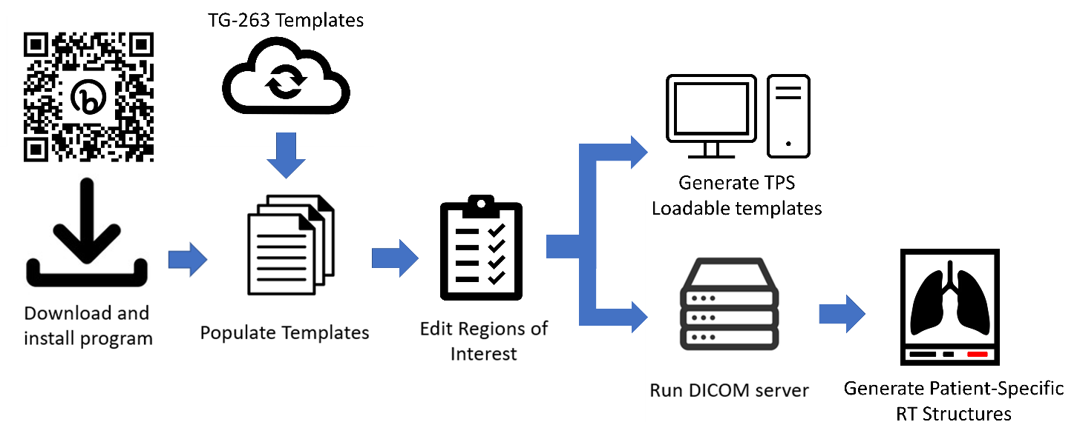

Figure 1: General workflow of the program. A visualization of each step from the program can be found in the supplementary document.